**DA Assignment 4**

**NAME: G.DEVENDRA REDDY**

**ROLL NO: 20KH1A0533**

**Creating Fixed LOD expression:**

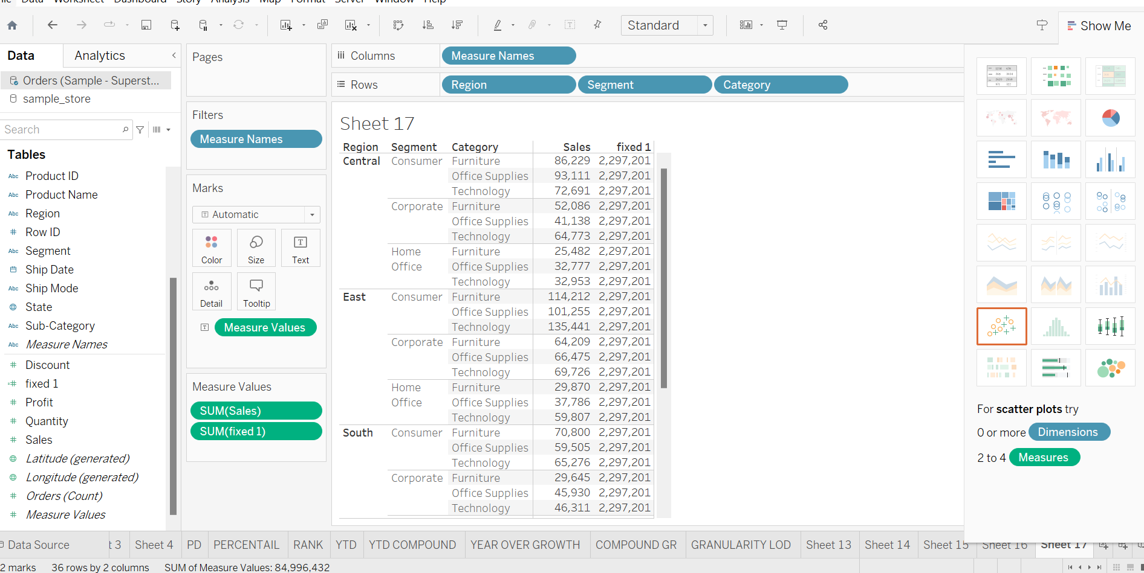

A fixed LOD (Level of Detail) expression in data analysis is a calculation that maintains a specific level of detail regardless of other dimensions or filters applied to the data. It provides a consistent reference point for aggregation.

Fixed LOD maintains a specific level of detail.

{fixed:sum(sales)}:

Sales distribution by fixed level of detail: calculates the sum of sales at a fixed level of granularity, independent of visuvalization’s dimensions.

**Creating exclude LOD expression**

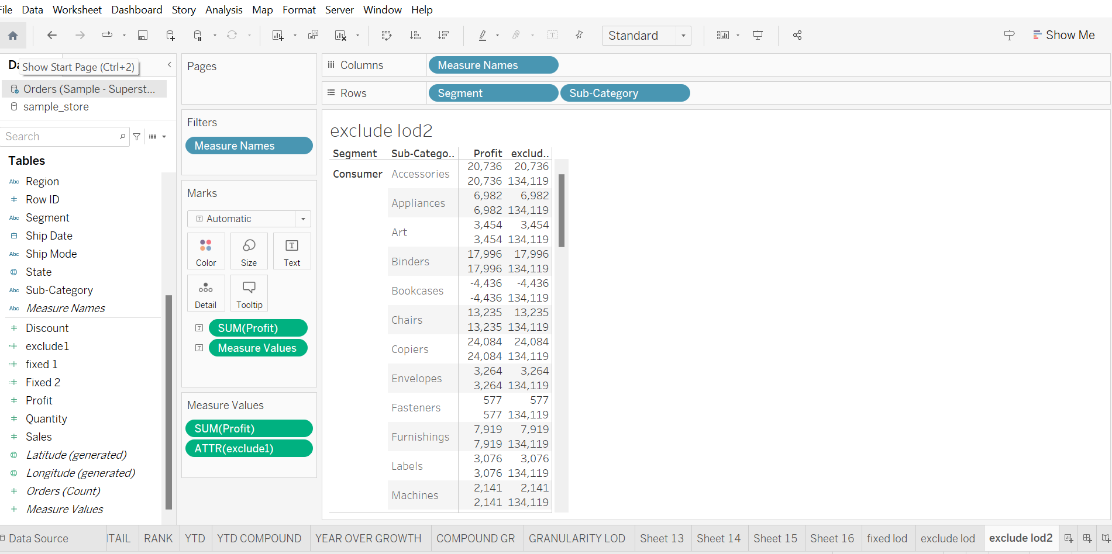

Exclude LOD expression calculates a value excluding certain dimensions from consideration. It allows for aggregations that ignore specific dimensions, offering a different perspective on the data.

Exclude LOD disregards certain dimensions in the calculations

**{Exclude[sub-category]: sum([profit])}**

**Exclude [sub category]:** This is designed to exclude the “sub-category” dimensions.

**SUM [Profit]:** The aggregation function “sum ()” is applied to “profit” values. It sums up all the profit values.

**Creating 2 map visualizations using geographical data.**

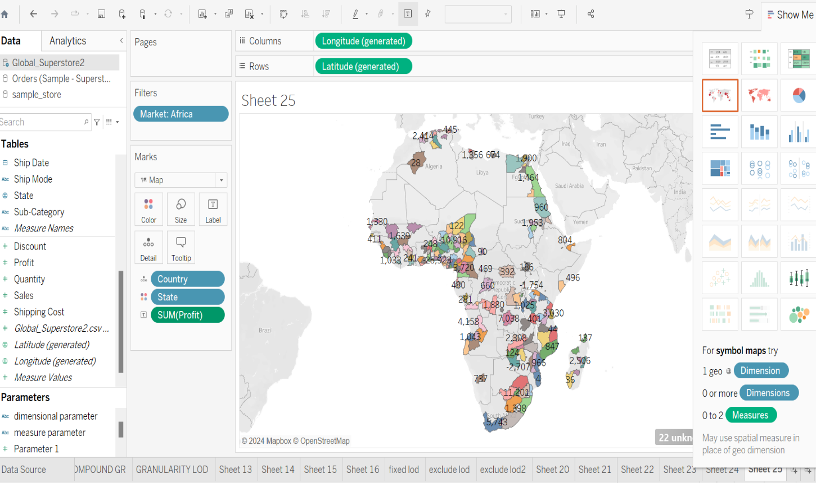**FILLED MAP:**

Here I have created a filled map visuvalization first fall I have taken a global store data set which likely contains information about sales, profits, and other metrics across different countries and regions.

I have drag a column as longitude and row as latitude .I have drag the country, state ,profit to mark I gave a colour to states and and I have drag a market to filter I have selected Africa as country .

Finally filled map visualization that effectively communicates information about profits across different states within the selected African market. This visualization can help stakeholders gain insights into regional profitability trends and make informed decisions based on the data.

SYMBOL MAP:

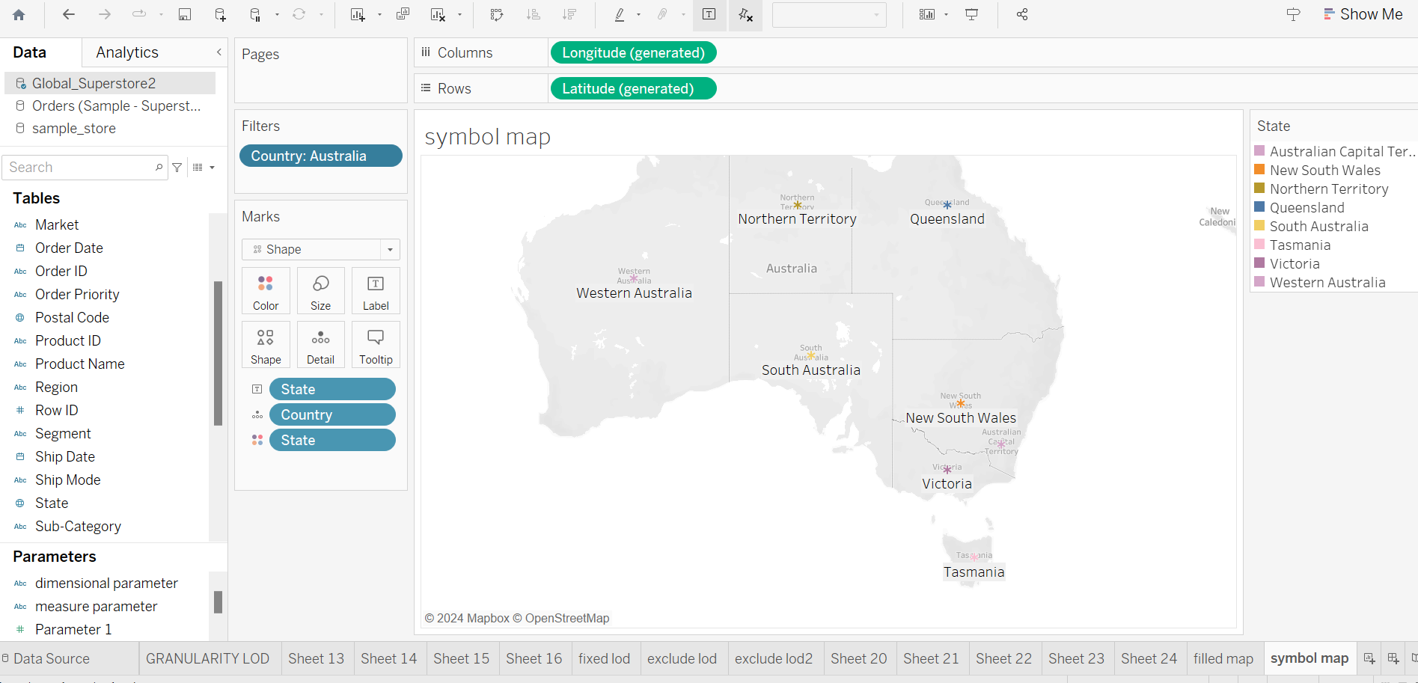

Here I have created a symbol map visuvalization first fall I have taken a global store data set which likely contains information about sales, profits, and other metrics across different countries and regions.

I have drag a column as longitude and row as latitude. I have drag the country, state ,profit to mark I gave a colour to states and and I have drag a market to filter I have selected Australia as country .And I have enter a shapes in search bar of marks and selected * symbol to create a symbol map.

Symbol map visuvalization for Australia power full tool for strategic decision making,market analysis and operational opitimization.

Top of Form

Top of Form

**Creating Top N Parameters**

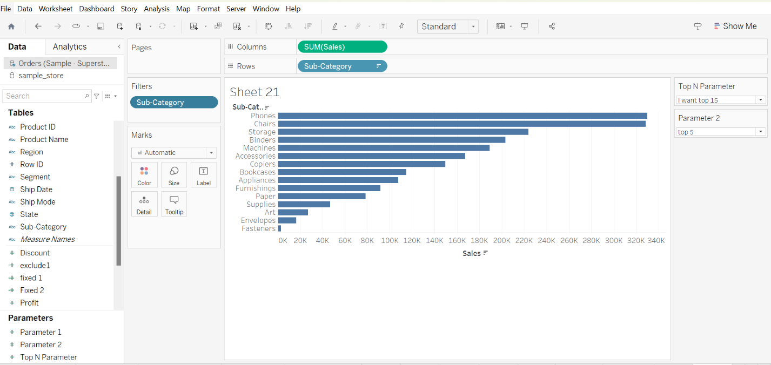

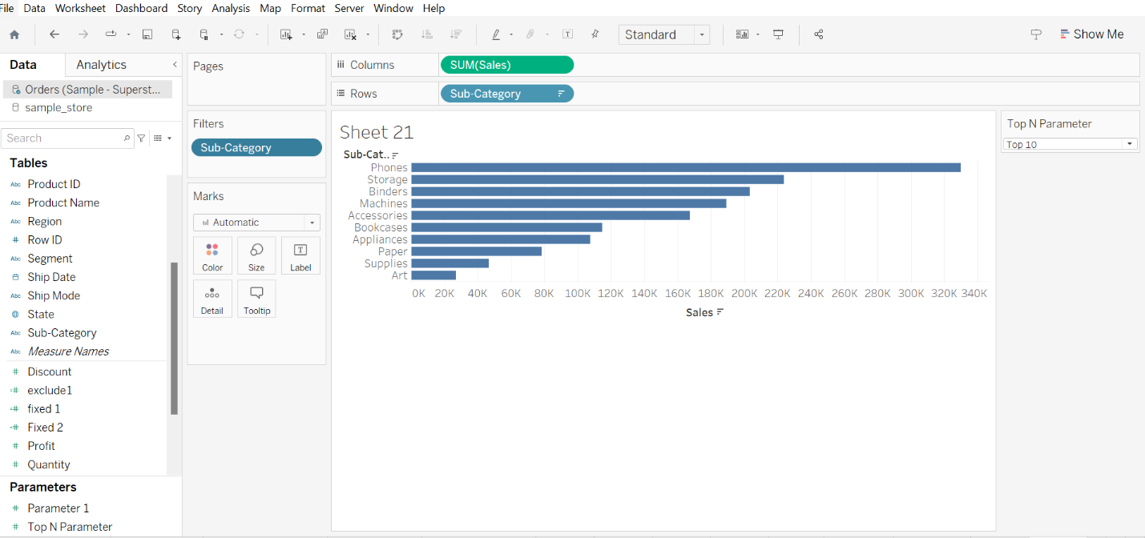

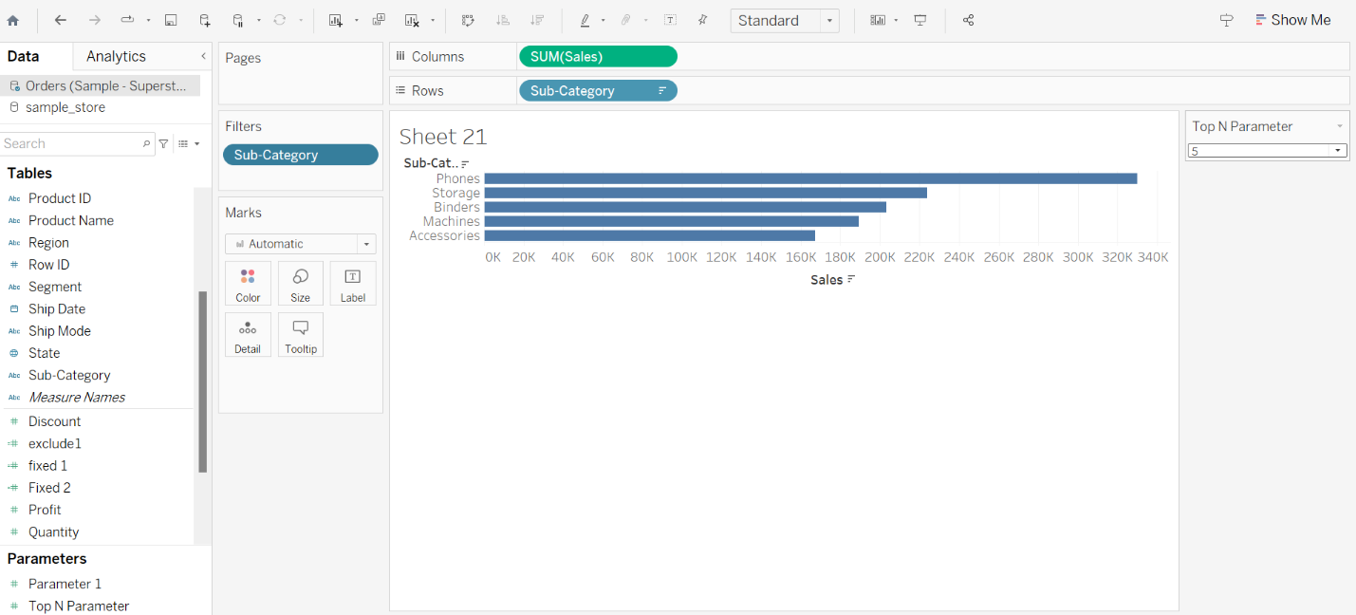First of all I have to select the sample store data set. And drag the sales to column and row to sub category. Drop down the creating a parameters and select the integer in the field and select the list opition and add the data like I want top 5 and top 10 and top 5 in that place. Click on ok and I have created finally top n parameter. Now we have to click on that and go to show parameters and we have opitions we cam click on that we get Top 15,Top 10,Top 5 subcategories. Focus on most significant data points and gain insights.

**Dimensional parameters**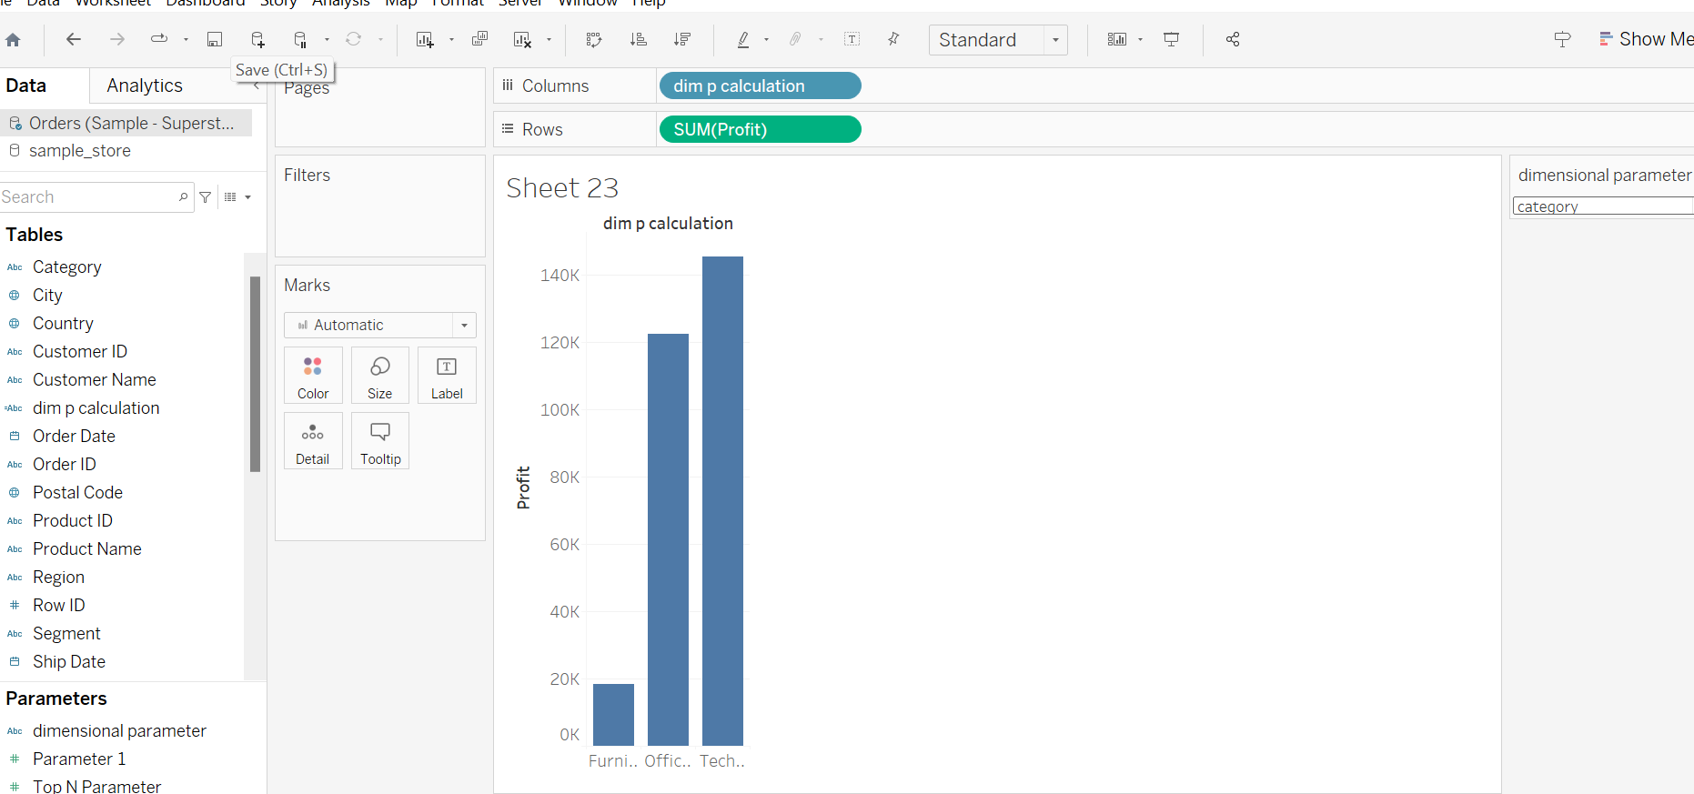

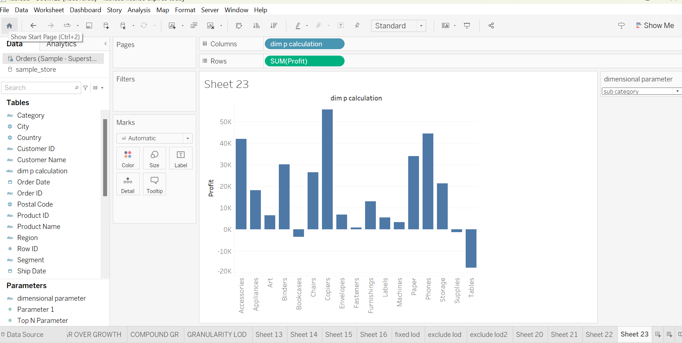

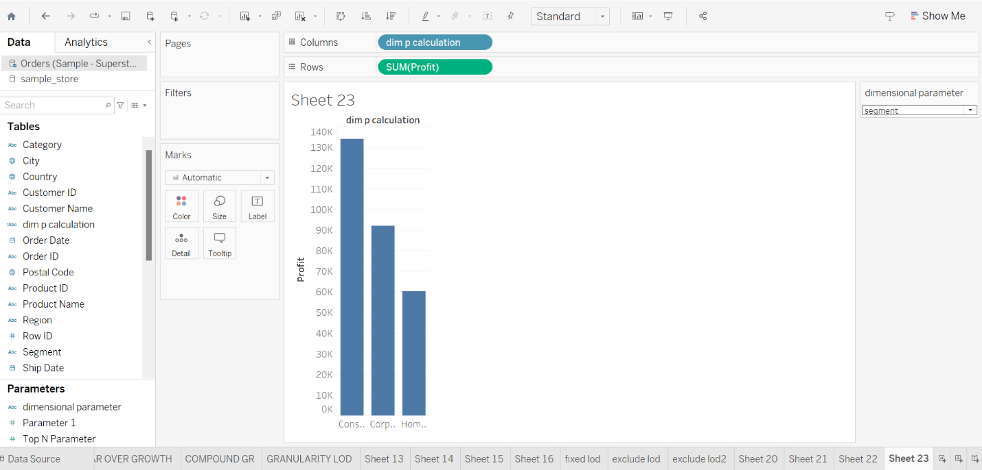**calculated field formula:** IF [dimension parameter]=”category” THEN[category] ELSEIF[dimension parameter]=”subcategory” THEN [sub category] ELSEIF[dimension parameter]=”segment” THEN[segment]END

**MEASURE PARAMETERS:**

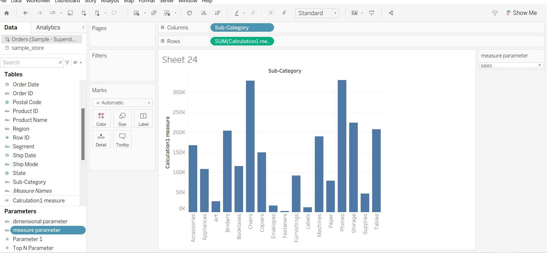

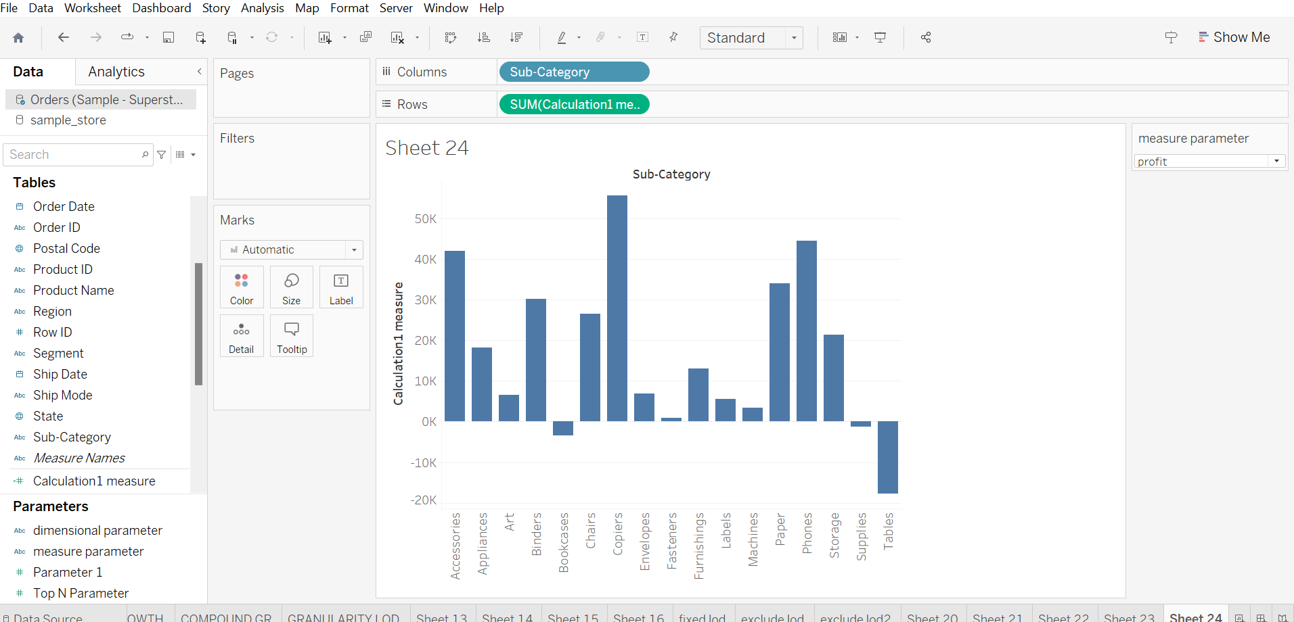

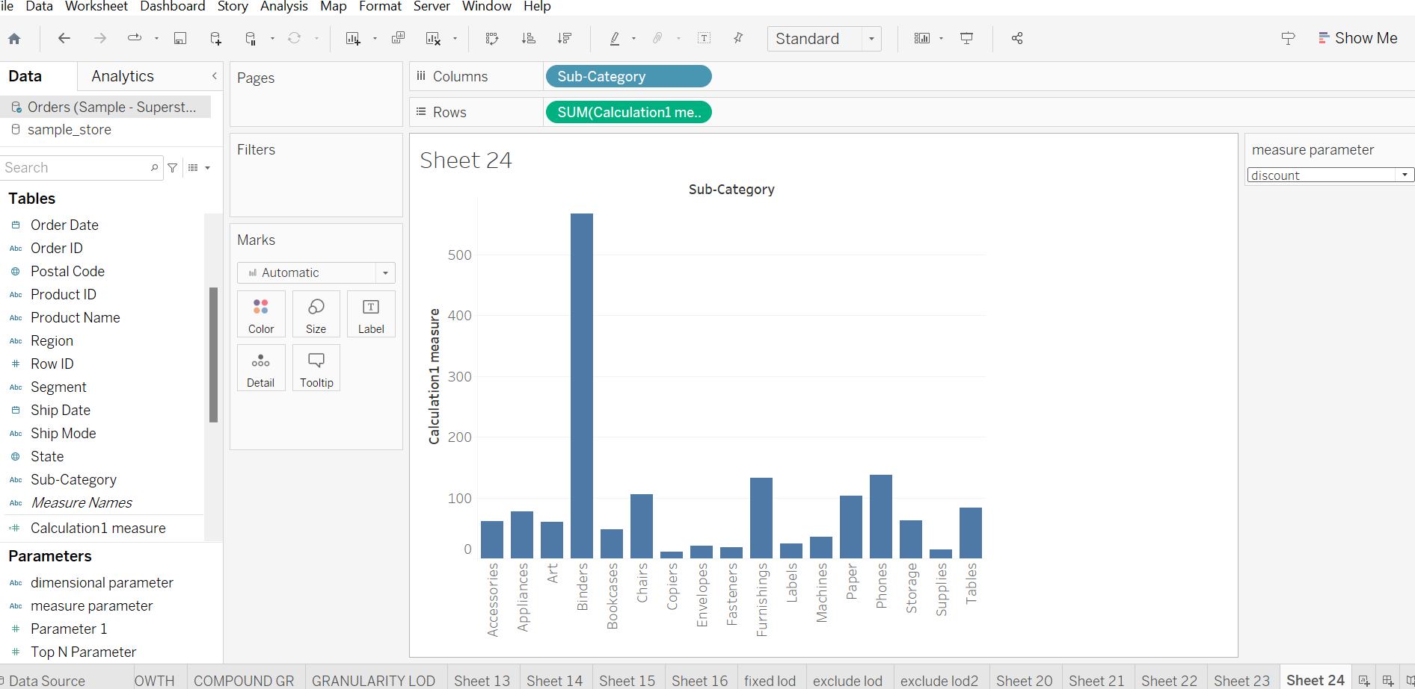

**Calculated field:** IF [measure parameter]=”sales” THEN[sales] ELSEIF[measure parameter]=”profit” THEN [profit] ELSEIF[measure parameter]=”discount” THEN[discount]END